AI ASSISTED CODING 12.4

NAME:TAHIYA MAHEROZE

ROLLNO:2403A52349

Task1: Write a Python implementation of **Bubble Sort**

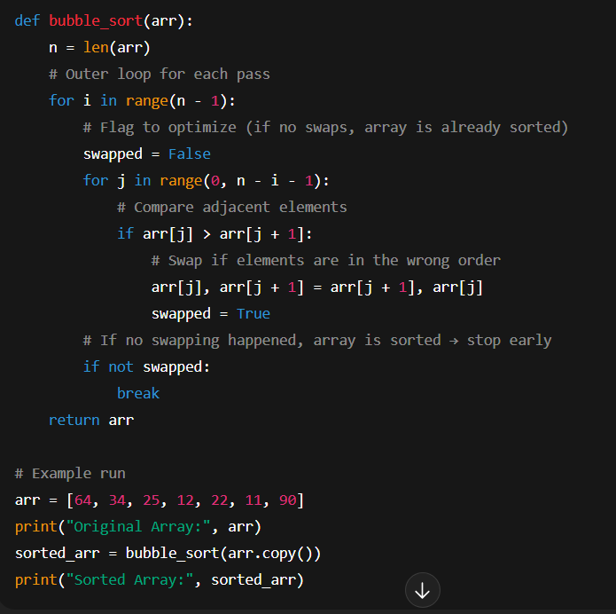

Output:

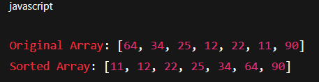

Task2: Provide Bubble Sort code to AI and ask it to suggest a **more efficient algorithm** for partially sorted arrays.

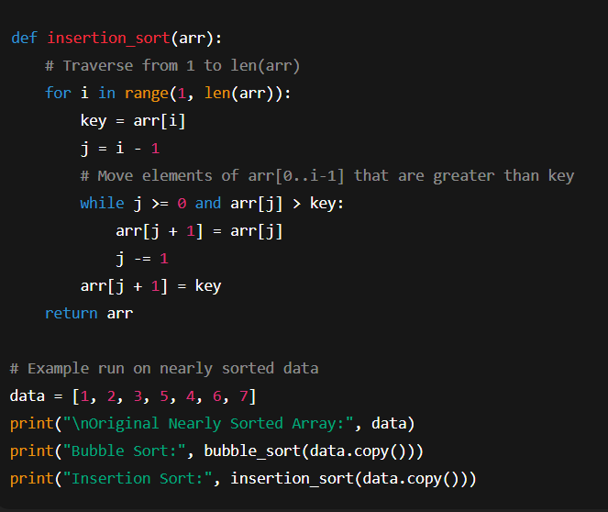

Output:

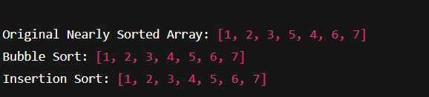

Task3: Implement both **Linear Search** and **Binary Search**

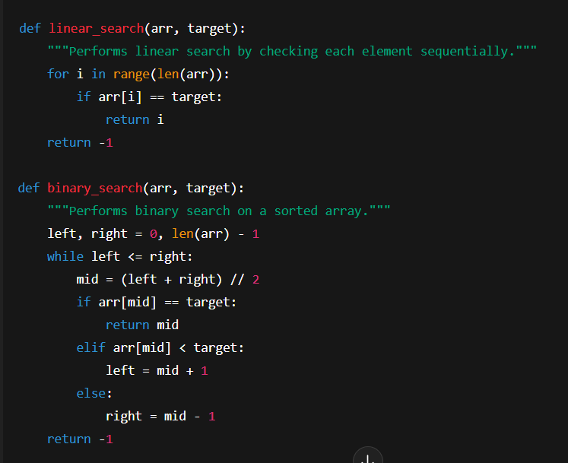

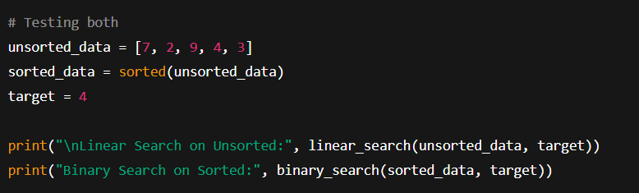

Output:



Task4:Implement Quick Sort and Merge Sort using recursion

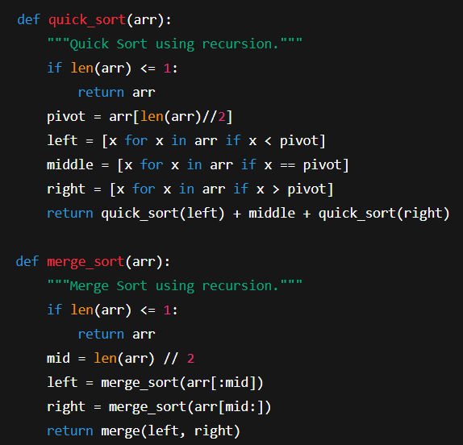

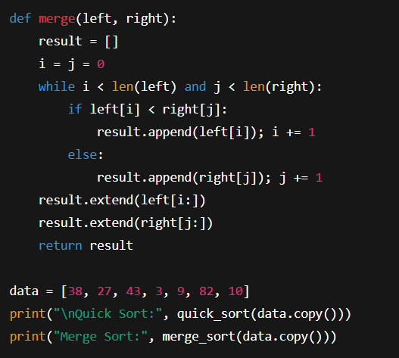

Output:

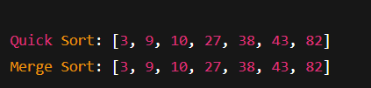

Task5: Give AI a naive algorithm (e.g., O(n²) duplicate search).

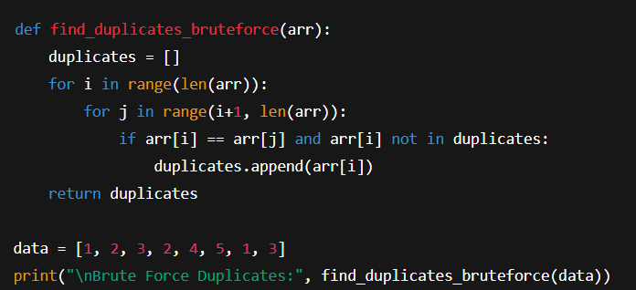

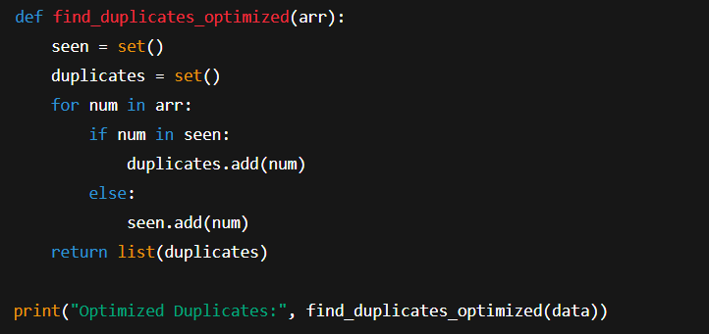

Output:

